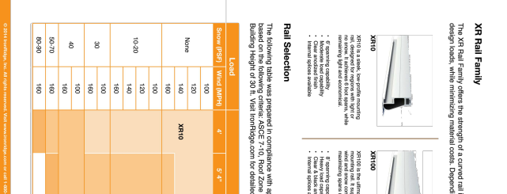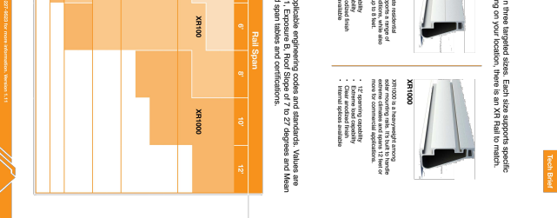
DD
^{RAWN B}Y | ^{RAWN DAT}E
^{S}K | ^{12/3/202}4

^{RE}V
^{(25) ENPHASE IQ8PLUS-72-2-U}_{S} ^{CONTRACTO}_{R} ^{PROJECT NAME & ADDRES}S ^{UNITED CONSTRUCTION} & ^{RESTORATIO}N ^{APN #: 06 552517}₆ ^{AHJ: PRINCE GEORGE'S COUNT}_{Y} ^{UTILITY: PEPC}_{O} ^{ZALMA ROS}_{S} ^{5701 DEER POND LN}, ^{CAMP SPRINGS, MD 2074}6
^{DC SIZE: 10.875 KW DC-(STC}₎ ^{AC SIZE: 7.250 KW A}C
(25) Q CELLS Q.TRON BLK M-G2+ 435
^{RESOURC}_{E} ^{DOCUMENT}_{S} ^{R-0}4^{SHEET TITL}E
^{SHEET NUMBE}R ^{SYSTEM DETAIL}S ^{PHONE - 301-615-039}₂ ^{LIC. NO. - MD 11135}2

^{DESCRIPTIO}N
D

^{REVISION}S
^{AT}E
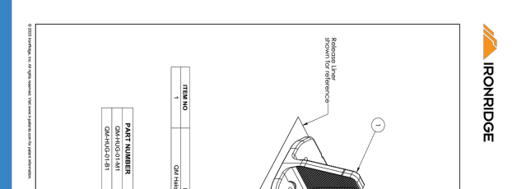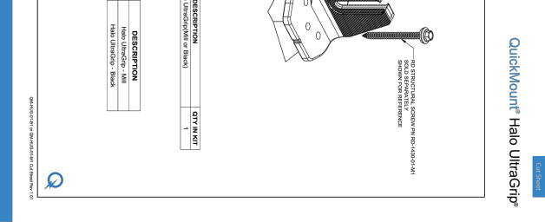
DD
^{RAWN B}Y | ^{RAWN DAT}E
^{S}K | ^{12/3/202}4

^{RE}V
^{(25) ENPHASE IQ8PLUS-72-2-U}_{S} ^{CONTRACTO}_{R} ^{PROJECT NAME & ADDRES}S ^{UNITED CONSTRUCTION} & ^{RESTORATIO}N ^{APN #: 06 552517}₆ ^{AHJ: PRINCE GEORGE'S COUNT}_{Y} ^{UTILITY: PEPC}_{O} ^{ZALMA ROS}_{S} ^{5701 DEER POND LN}, ^{CAMP SPRINGS, MD 2074}6
^{DC SIZE: 10.875 KW DC-(STC}₎ ^{AC SIZE: 7.250 KW A}C
(25) Q CELLS Q.TRON BLK M-G2+ 435
^{RESOURC}_{E} ^{DOCUMENT}_{S} ^{R-0}5^{SHEET TITL}E
^{SHEET NUMBE}R ^{SYSTEM DETAIL}S ^{PHONE - 301-615-039}₂ ^{LIC. NO. - MD 11135}2

^{DESCRIPTIO}N
D

^{REVISION}S
^{AT}E

